Application Number | 07/2019/0458/HOH
Address | 36 Howick Cross Lane  Penwortham
Applicant | Mr E Rampling

Agent Mr J Mulkerrin
250 Dill Hall Lane
Accrington
BB5 4DG
Development | First floor side extension above existing garage
Officer Recommendation | Approval with Conditions

Date application valid | 18.1.19
Target Determination Date | 15.3.19
Extension of Time | None

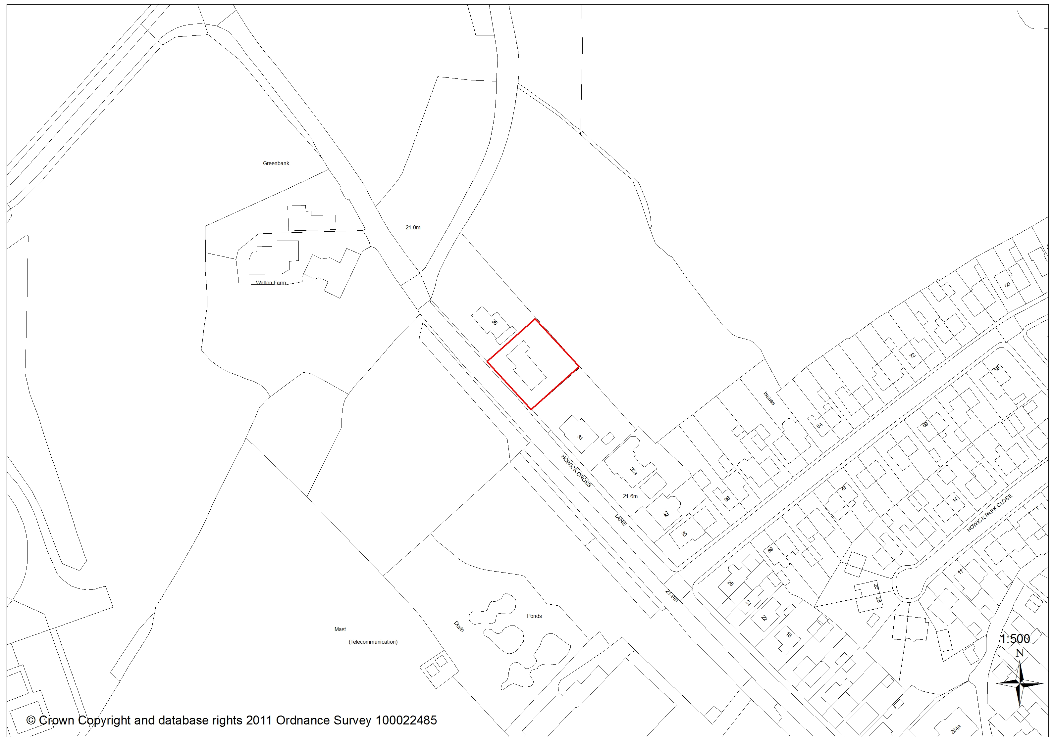

- Introduction

  - This application is brought before committee as the applicant regularly works as a Council contractor.

- Report Summary

  - The application proposes erection of first floor side extension over an existing, attached garage.

  - The scheme has been well designed, relates well to both the main dwelling and wider environment and retains acceptable levels of amenity and parking space. The proposal complies with the relevant policies of the South Ribble Local Plan, Rural Development and Residential Design SPD’s and is recommended for approval subject to conditions

- Application Site and Surrounding Area

  - The application refers to a detached dormer bungalow, located within a semi-rural location allocated as Green Belt by Policy G1 of the South Ribble Local Plan.

  - Adjacent in the north-west is no 38 – a large detached dwelling whose gable wall sits alongside that of the applicant’s property. In the south-east is no: 34; again a large detached dwelling but which benefits from mature tree screening, and both the applicants and their own deep side gardens.

  - To the rear and facing across Howick Cross Lane are deep tracts of open land.

- Site Context / Planning History

  - There is only one application on the planning history for this site. Application 07/2013/0450/HOH for erection of pitched roofs over dormers was approved August 2013.

- Proposal

  - The application seeks permission for erection of a first floor extension to the side. The extension would measure 5.8m in width x 4.2m deep, with a maximum roof height of 7.3m to line in with the existing roof. Eaves are relatively low at 2.4m and the whole would be constructed in materials to match the main property

  - Pitch roofed dormers to match the existing would be installed into both front and rear elevations

- Representations

  - Neighbour Consultation

    - Two neighbouring properties have been consulted but representation has not been made.

  - Statutory Consultee Responses

    - On this occasions consultation was not felt necessary.

- Material Considerations

  - Relevant Policy

    - The site is designated as Green Belt by Policy G1 of the South Ribble Local Plan.
    - Policy G1 in accordance with the NPPF (2018) includes a general presumption against any development which harms green belt openness. There are exceptions to this stance however, and in this case exemption (c) which allows for ‘the extension or alteration of a building provided that it does not result in disproportionate additions over and above the size of the original building’ applies. Development which does not benefit from exemption will be considered unacceptable unless it can be demonstrated that there are very special circumstances which outweigh the harm caused.

    - G1 is supported by the Central Lancashire Rural Development SPD which accepts the extension and alteration of dwellings providing they do not result in disproportionate additions over and above the size of the original building. Proposals which have an increase of over 50% of the volume of the original building (as at 1948) will be considered inappropriate.

    - Policy G17 of the Local Plan also considers the visual impact of a proposal on the immediate surroundings but in design terms, whilst Policy F1 ensures adequate off road parking provision in line with adopted standards

    - Additions to the property (including proposed extension and earlier dormers) amount to a little over 36%, and it is considered that proposed alterations constitute relatively minor additions which impact little on the areas openness. The proposal would relate well to neighbouring buildings and has been designed in appropriate materials which offers visual betterment to the property. Off road parking provision would not change but is more than adequate at three spaces, and the proposal will not impact upon amenity space in any way. As such the proposal is considered compliant with the relevant policies of the Local Plan and the Rural Development SPD.

  - Relationship To Neighbouring Properties

    - The proposed blank gable wall would face the blank gable to no: 38 Howick Cross Lane at 4m distance. Separation would be the same as existing and adverse impact as a result is unlikely.

    - No: 34 sits to the opposite side of the property, and is well screened by deep side gardens with mature planting, and the applicants own property.

    - Spatial separation to these properties has been assessed against the requirements of the Residential Design Guide and impact by virtue of loss of privacy, light or overlooking is considered unlikely.

- Conclusion

  - This scheme has been well designed, relates well to both the main dwelling and wider environment and retains acceptable levels of amenity and parking space. The proposal complies with the relevant policies of the South Ribble Local Plan, Rural Development and Residential Design SPD and is recommended for approval subject to conditions.

RECOMMENDATION:

Approval with Conditions.

RECOMMENDED CONDITIONS:

1. The development hereby permitted must be begun not later than the expiration of three years beginning with the date of this permission.
REASON: Required to be imposed pursuant to Section 91 of the Town and Country Planning Act 1990.

2. The development hereby permitted shall be carried out in accordance with approved plans B101, B102, B103 & B104 (Autodesk)
REASON: For the avoidance of doubt and to ensure a satisfactory standard of development in accordance with Policy 17 of the Central Lancashire Core Strategy and Local Plan 2012-2026 Policy G17

- All external facing materials shall match in colour, form and texture to those on the existing building.
REASON: In the interests of the visual amenity of the area and so that the Local Planning Authority shall be satisfied as to the details in accordance with Policy 17 in the Central Lancashire Core Strategy and Policy G17 in the South Ribble Local Plan 2012-2026

RELEVANT POLICY

National Planning Policy Framework

South Ribble Local Plan
F1 Car Parking
G1 Green Belt
G17 Design Criteria for New Development

South Ribble Residential Design SPD

Central Lancashire Rural Development SPD

